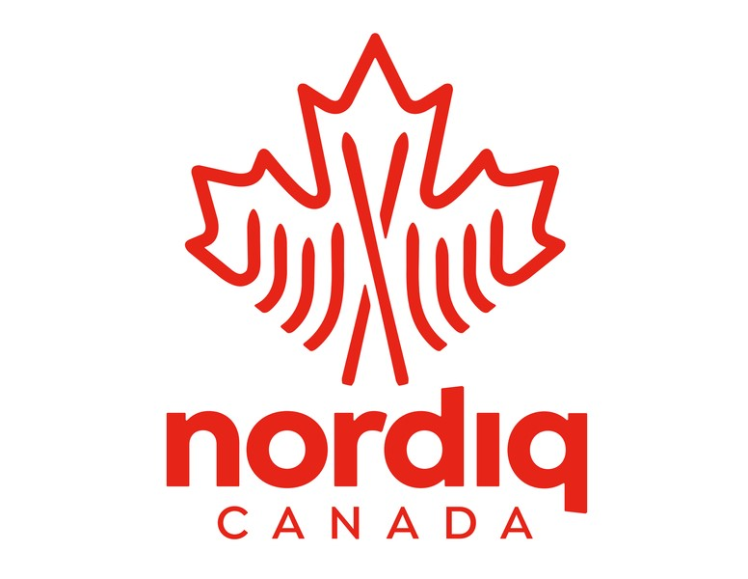
Nordiq Canada Homologation Application:

This document represents an agreement between the identified club or organization and Nordiq Canada to seek FIS homologation as outlined in the Nordiq Canada Homologation Guidelines for the specific courses identified below.

Upon receipt of this signed application Nordiq Canada will issue an invoice by email based on the costs outlined below plus GST. Once processed, a Homologation Inspector will be assigned to your project. If the initial plan outlined below should change prior to the final submission to FIS then adjustments will be made accordingly through either an additional invoice or a refund. For more information, please contact Ilona Gyapay, Events and Officials Manager, igyapay@nordiqcanada,ca.

Please note that the fees assigned to this agreement do not include the expenses and costs associated with the visits by your appointed Homologation Inspector (HI). The HI will invoice the club separately. These additional costs are explained in the Nordiq Canada Homologation Guidelines and any travel by personal vehicle can be charged in accordance with Nordiq Canada’s Travel and Expense Policy, currently set at $.45/km.

Club/Organization Name | >
Trail Facility Location | >
Name of Key Contact (for HG process) | >
Email for Key Contact | >
Briefly describe the scope of work that is planned in support of this homologation request:
>
Expected completion date(s):
>
Specific courses being submitted for homologation:
Course Name | Distance (km)  (loop length only) | Ski technique  (Cl, F, Both) | Race Formats to be used with this course. | Reg fee  $170 per course
 |  |  |  | $170
(insert more rows above if needed) Nordiq Canada /FIS Application Fee |  |  |  | $200
This total plus GST to be invoiced by Nordiq Canada
Total

Assigned Homologation Inspector:
Email:

Signed by Key Contact or Club Authority: _________________________________

Date: _________________________________
Please return this Homologation Request directly to Ilona Gyapay, igyapay@nordiqcanada.ca and copy info@nordiqcanada.ca. Thank you.

