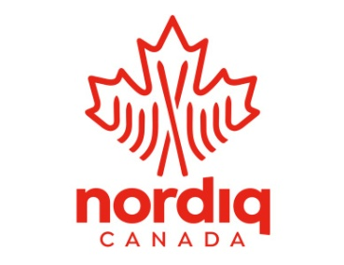

Nordiq Canada OFFICIALS LEVEL 3 CERTIFICATION COURSE

Winter 2023-2024

This facilitated course will combine:
- A series of expert-led zoom sessions and participant presentations, throughout the winter, beginning in November.
- On-site FIS event observation assignments (location TBD– Either, Western Canadian Championships, Canmore, or Canadian Ski Nationals, Nakkertok).
- Pre and post course assignments complete the evaluation components of this course.

Confirmation of candidates and provisional agenda will occur beginning of September, with Candidates to confirm their spots and submit payment by September 30th.

The completion of the course enables participants to embark in two streams: Event Organizer or Nordiq Canada Divisional TD

TARGET PARTICIPANTS:
- Qualified Level 2 Officials seeking Level 3 certification requires your Division recommendation (form below) which confirms your completion of Level 3 prerequisites as recorded in your experience log in the Nordiq Canada Officials Registry.
- Existing Level 3 and 4 Officials/TDs who have not been active or re-certified in 5 years or more: (≤2018) (e.g. worked as an official and/or as a Divisional TD in club, divisional, and/or National events, or not taken a Level 3 Officials Course, or attended a divisional or Nordiq Canada/FIS TD/OC update or Seminar Course.)
- Please note that if the course is over-subscribed (max 10) then participants will be selected based on their levels and breadth of officiating experience as noted in their Officials Registry documentation.

Level 3 Official – EVENT ORGANIZER

A Level 3 official will be able to:
- Perform any “major official” role at the national-championship level and below;
- Effectively structure, staff and manage a competition- and event-organizing committee at the division through to the national level;
- Be familiar with the Nordiq Canada Regulations and Technical Packages and FIS rule book and make appropriate rule interpretations as they apply to Tier 1- and 2-level competitions;
- Be able to provide a risk-management assessment for a race site and develop an effective risk management plan; and
- Instruct the Level 1 and 2 officials’ clinics after having achieved certification.

PREREQUISISTS:
The course participant must:
- Be recommended by his/her division;
- Complete all requirements of the Level 3 Officials course;
- Have performed at least two different “major official” duties and at least three different “secondary official” duties at events at the division cup or national-championship (or equivalent) level (logbook documentation may be required); and
- Hold a Level 2 officials’ certification.

MAINTAINING CERTIFICATION:
- Maintain an active interest by working as a major official in club and divisional events at least two of every three years.
- Certification will be reviewed and re-assessed every five years.

Level 3 Official – TECHNICAL DELEGATE (TD)– NORDIQ CANADA DIVISIONAL TD

A Level 3 TD will be able to:
- Perform the role of a Divisional Technical Delegate for events which require the overseeing and performing of all aspects of officiating at the division level for division cup and popular cross-country ski (loppet) competitions; and
- Perform all roles described for a Level 3 Event Organiser (above).

PREREQUISITS:
- Same as above

CERTIFICATION:
- Meet the prerequisite requirements of the Level 3 officials course.
- Complete all requirements of a Level 3 officials course.
- Complete one (1) divisional apprentice TD assignment or Jury-member role.
- Be an active skier, able to competently ski courses in both techniques to inspect and assess the quality of the course preparation and track setting.

TO MAINTAIN CERTIFICATION:
- Maintain active interest by working as an official and/or as a TD in club and divisional or provincial events two of every three years.
- Attend a Nordiq Canada TD, FIS TD or Division Level 3/TD update once every two years
- Be an active skier, able to ski courses, competently, in both techniques to inspect and assess the quality of the course preparation and track setting.

REGISTRATION PROCESS:

- Acquire your Division’s approval and email your application to Ilona Gyapay (igyapay@nordiqcanada.ca). (See attached form.) The application will be screened for pre-requisites and acceptance into the course based on the criteria above.
- Once you are notified of being accepted into the course, then pay the registration fee.
- Once payment has been completed you will receive your course access code (enrollment key). This permits you to register into the Level 3 course at the Nordiq Canada Officials E-Learning site https://cccofficials.moonami.com.

REGISTRATION FEE: $400.00

Agenda and course details will follow once candidates are confirmed.

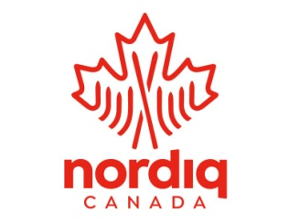

LEVEL 3 OFFICIAL- CANDIDATE’S PREREQUISITE & DECLARATION OF INTEREST FORM
AUGUST 20TH DEADLINE TO SUBMIT

Nordiq Canada OFFICIALS COURSE – LEVEL 3
Winter 2023-2024

Complete and send as an email attachment to:
Ilona Gyapay – igyapay@nordiqcanada.ca

Candidate’s Name: __________ Candidate’s Email: ________________

Candidate’s Division: ________
Division Rep. Authorization provided by: _______________ (Please provide full name)

Division Reps. Phone #: ____________ Division Reps. Email: ________________

A short summary of your most recent officiating experiences involving major roles and minor roles (include the year). (This list should fulfill the prerequisite requirement outlined below. PLEASE READ CAREFULLY)

- ___________

- ___________

- ___________

- ___________

Quick Reference:

PREREQUISITES of Level 2 candidates for Level 3 Certification:

- Be recommended by his/her Division
- Have performed at least two different “major official” duties and at least three different “secondary official” duties at the division cup or national championships (or equivalent) level events (Your ‘Experience Log’ on the Nordiq Canada Officials Registry site must be updated accordingly with these details).
- Hold Level 2 officials certification.

