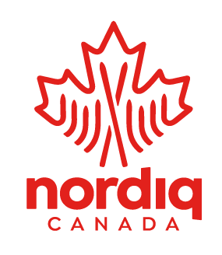
2021 Jackrabbit Toque Design Contest

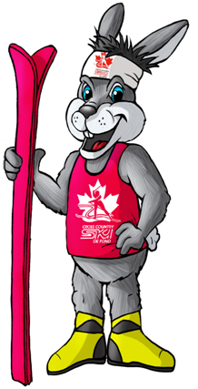
Hello Jackrabbits!
Please use the square below to draw a design that will inspire all Jackrabbits across the country to always try their best!
We will put the top 10 designs on Survey Monkey for a vote by all Nordiq Canada members to decide the JR toque of 2021! Good luck and happy winter!

Jackrabbit name: __________________ Email:________________________
Age:____ Phone number:____________ Mailing address:_________________
Which club do you belong to?________________________________________
Before you start!
- Clear lines show up best
*The design will be printed randomly on the toque, and may be altered from the original design*

Please submit design by noon, MST on March 11, 2020 to: igyapay@nordiqcanada.ca and participate in the voting process from March 11, 2020 to March 18, 2020 noon, MST, via Survey Monkey! The 2021 winning design will be posted on the Nordiq Canada website and Facebook.

