
STRENGTH TESTING PROTOCOL
(updated Oct 31st 2011)

Description:

Duration: 1 min on, 1 min off, start to finish

Sequence: must be in the following order:

1- Pull-ups: pronation grip (back of hands facing you); grip wider than shoulder width to allow 90⁰ angle when upper arms are parallel to the ground; legs bent at knee level is allowed but no swinging with the legs allowed during pull-ups; chin must be raised above the bar with each pull-up to score one rep. | 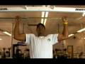
2- Sit ups: knees bent at 90⁰ and feet anchored; arms crossed in front with hands holding opposite shoulder; elbows must touch knees no further down than 10cm from top of knee to score one rep. ; lower tip of shoulder blades need to touch ground between each rep. | 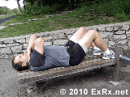
3- Push-ups: stand on hands just outside shoulder width; the upper arm must be parallel to the floor at the lowest point and full extension at the highest point; whole body must remain fairly straight through the test. | 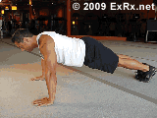
4- Box jumps: feet together top of box at 16 inches (40 cm) off the ground; more than half of feet length must land on the top of the box so there is some pressure applied on the heels | 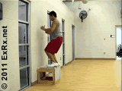
5- Dips: grip and arms motion as with push-ups; arms and feet elevated off the floor | 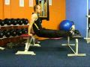

**In order for Cross Country Canada to keep National Standards per age updated please e-mail results and specific birth year for each participant to sbarrette@cccski.com. Athletes names will not be published, only averages per age will be added to the database. Coaches, it is important to explain to athletes that this is an individual test and results should be used to compare individual progress and the effectiveness of prescribed programs.

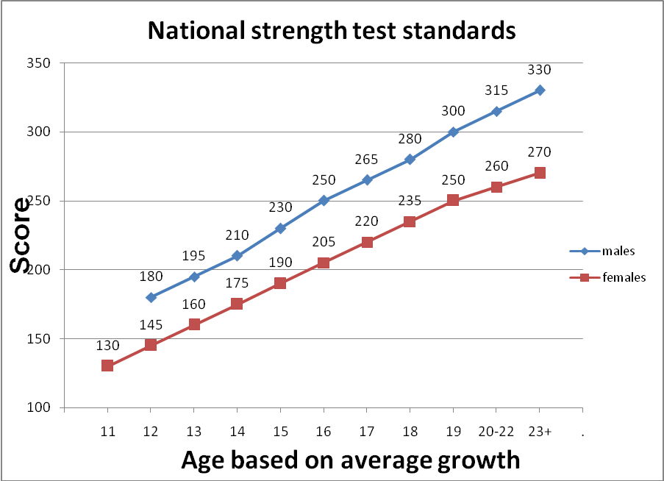

Detailed standards per exercise

FEMALE |  |  |  |  |  | MALE
AGE | Pull-ups | Sit-ups | Push-ups | Box Jumps | Dips | AGE | Pull-ups | Sit-ups | Push-ups | Box Jumps | Dips
23+ | 20 | 60 | 45 | 60 | 45 | 23+ | 30 | 60 | 55 | 65 | 60
20-22 | 18 | 60 | 40 | 60 | 45 | 20-22 | 27 | 60 | 50 | 65 | 60
19 | 17 | 60 | 40 | 55 | 45 | 19 | 25 | 60 | 50 | 60 | 55
18 | 16 | 55 | 35 | 55 | 40 | 18 | 22 | 55 | 45 | 60 | 55
17 | 13 | 55 | 35 | 50 | 40 | 17 | 19 | 55 | 45 | 60 | 50
16 | 10 | 50 | 35 | 50 | 40 | 16 | 16 | 55 | 40 | 55 | 50
15 | 8 | 50 | 30 | 50 | 35 | 15 | 13 | 50 | 40 | 55 | 45
14 | 7 | 45 | 30 | 45 | 35 | 14 | 10 | 50 | 35 | 50 | 45
13 | 6 | 40 | 30 | 40 | 30 | 13 | 8 | 45 | 35 | 50 | 40
12 | 5 | 40 | 25 | 35 | 30 | 12 | 6 | 45 | 30 | 45 | 40
11 | 4 | 35 | 25 | 35 | 25

 |  |  |  | STRENGTH TEST TEMPLATE
Date:
Club and location of test:
Color code for test interpretation and training program guidance:
 | meets standard
 | less than 10% from standard
 | 11 to 20% from standard
 | over 20% from standard
AGE  in 2007 | gender | Name | Pull-ups(x3) | Sit-ups | Push-ups | Box Jumps | Dips | TOTAL PTS | std | diff | gap

EXAMPLE:

Date: | July 6th 2006
Club and location of test: |  |  | Big biceps club, Pumping Iron city
Color code for test interpretation and training program guidance:
 | meets standard
 | less than 10% from standard
 | 11 to 20% from standard
 | over 20% from standard
AGE  in 2007 | gender | Name | Pull-ups(x3) | Sit-ups | Push-ups | Box Jumps | Dips | TOTAL PTS | std | diff | gap
15 | F | Jasmine | 10 | 47 | 43 | 66 | 36 | 222 | 190 | +32 | +17%
17 | F | Jennifer | 6 | 54 | 36 | 56 | 36 | 200 | 220 | -20 | -9%
15 | F | Jane | 4 | 49 | 46 | 50 | 37 | 194 | 190 | +4 | +2%
19 | M | Jack | 19 | 50 | 48 | 57 | 70 | 282 | 300 | -18 | -6%
15 | M | Joe | 11 | 38 | 43 | 51 | 37 | 202 | 230 | -28 | -12%
20 | M | Jim | 26 | 57 | 66 | 61 | 60 | 322 | 315 | +7 | +2%
18 | M | John | 13 | 42 | 36 | 52 | 38 | 207 | 280 | -73 | -26%

